**5.5**

**Daulet’s part:**

This SQL query finds the number of visits of the patient, whose names are Daulet Kapezov. There possibly could be several people with that name, but here we have only one.

SELECT p.patientNo, COUNT(v.VisitNo)

FROM Patient p, Visit v

WHERE upper(p.name) = ‘DAULET KAPEZOV’ and upper(p.patientNo) = upper(v.patientNo)

GROUP BY p.patientNo;

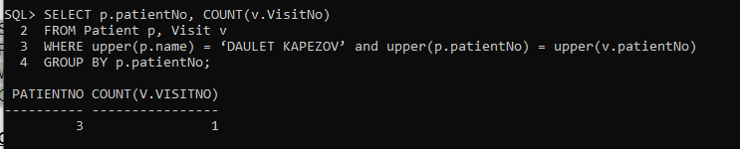

**Carlos’ Part**

This SQL query lists the appointments that Dr. Kevin Malone has conducted.

SELECT s.staffNo, s.name, s.title, a.apptdate

FROM Staff s, Appointment a

WHERE s.staffNo = a.staffNo and upper(s.name) = ‘KEVIN MALONE’;

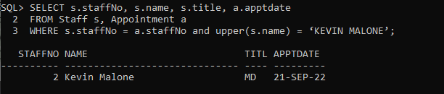

**Filippo’s part:**

This SQL query will show what the X-mount of dollar was for:

SELECT p.name , b.totalAmount, c.amountCharged

FROM Charge c, Bill b , patient p

WHERE b.totalAmount > 1000 and c.amountCharged > 1000 and b.patientNo = p.patientNo and c.invoiceNo = b.invoiceNo;

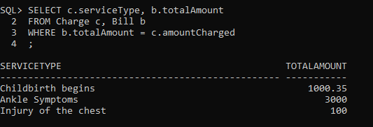

This SQL query will show the totalAmount which is greater than average totalAmount.:

SELECT p.name, b.totalAmount

FROM patient p,

Bill b

WHERE p.patientNo = b.patientNo and b.totalAmount > ( SELECT avg(b.totalAmount)

FROM Bill b);

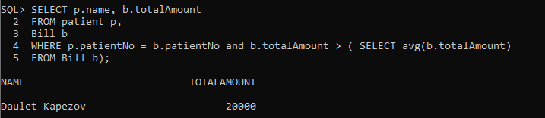

**Christina’s Part:**

This query will show the diagnosis name for each patient’s visit.

SELECT p.Name, dm.diagName

FROM patient p,

visit v,

diagnosis d,

diagnosisMenu dm

WHERE v.visitNo = d.visitNo and p.patientNo = v.patientNo and dm.diagCode = d.diagCode

ORDER BY p.name;

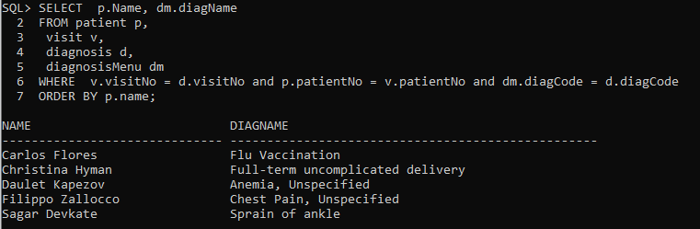

Query will show the avg patients pay for their insurance prescription co-pay

SELECT p.patientNo, p.patient, name,

**5.6**

I haven’t checked it yet, so I am not sure about that.

And I have just realized that it might be totalAmount = $\sum_{i =1}^{N}{}amountPaid$- amountCharged, but it was realized as totalAmount = $\sum_{i =1}^{N}{}amountPaid$.

CREATE OR REPLACE TRIGGER sumAmountTotal

AFTER INSERT ON Payment

REFERENCING NEW AS NEW OLD AS OLD

FOR EACH ROW

BEGIN

UPDATE Bill

SET totalAmount = (totalAmount + :NEW.amountPaid), amountPaid = :NEW.amountPaid

WHERE :NEW.patientPayer = patientNo;

END;

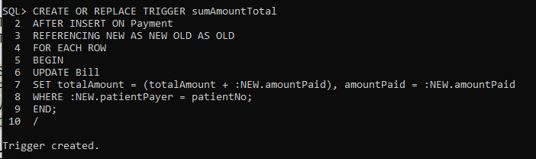

Before

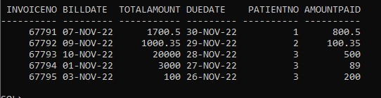

INSERT INTO Payment VALUES (67791, ‘7-DEC–2022’, 1000.00, 1 , ‘Blue Shield’, 13452);

